Dawn Chorus with Pip Wright
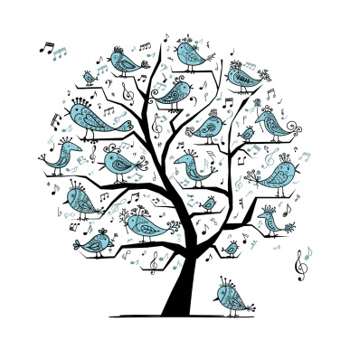
Fridays 10.00 - 11.30am @ Marazion Community Centre
Lyrics

No Hopers, Jokers and Rogues
by Rupert Christie and Tom Gilbert of Fishermans Friends (arr. Anna Tabbush)

Chorus:
Come on you no hopers, you jokers and rogues
We're on the road to nowhere
Let's find out where it goes
It might be a ladder to the stars, who knows
Come on you no hopers, you jokers and rogues

- Leave all your furrows in the fields where they lie
Your factories and offices, kiss them all goodbye
Have a little faith in the dream-maker in the sky
There's glory in believing him
And it's all in the beholder's eye Chorus

- Turn off your engines and slow down your wheels
Suddenly your master plan loses its appeal
Everybody knows that this reality's not real
So raise a glass to all things past
And celebrate how good it feels Chorus

- Awash in the sea of our own vanity
We should rejoice in our individuality
Though it's gale force
Let's steer a course for sanity Chorus

United by Sue Harris (inspired by the words of Jo Cox

Sop,Alto & Tenor:
We are far more united, we are far more united
*And have far more in common … far more in common … than that which divides us
Unite! Unite! Unite! Unite! (repeated …)
We are far more United

Bass line 2:
*And have far more … far more … more in common … than that which divides us

pipjanewright@gmail.com www.pipwright.co.uk

Dawn Chorus - LYRICS

- This is Home (Sophia Efthimiou)
This is home where I belong, in this breath, in this heart
This is home where I belong, in this voice, in this song

- In the beauty of the World (Jane Harris)
In the beauty of the world find rest and be free (x 2)
(V.2 in the grace/ V.3 in the peace)

- Keep your heart good (Nickomo)
Keep your heart good in the bad times,
Keep your heart good when the bad times come
Keep your heart good in the bad times, ‘til they’re gone, gone, gone

- Let it go (Suzann Frisk & Michael Leunig)
Let it go, let it out, Let it all unravel
Let it free and it can be, A path on which to travel

- Listen (Nick Prater)
Listen, listen to the voice of your heart (x 2)

- Na Hey (Orcadian mourning song)
Na Hey, Na hey, Na hey, Na hey na (x 2)

- Nobody’s Fault but Mine (Trad gospel / blues arr. Gitika Partington)
… we will learn it by ear

- Reassurance (Pip)
You’re here, you’re safe, you’re welcome, you matter

- Shine on me (Trad, Harps of Melody arr. Tony Backhouse)
Shine on me, shine one me, let the light from the lighthouse shine on me

- Souallé (‘Goodnight’ Lullaby from West Africa)
Souallé, Souallé, Souallé, Souallé (x 3)

- Stronger (Helen Yeomans)
Stronger, I believe that love is stronger, I believe that love is stronger,
I believe that love is stronger, I believe (it’s … stronger) / [in love]

- We are a circle (Rick Hamouris, arr. Barbara Swetina))
We are a circle, within a circle, with no beginning and never ending

pipjanewright@gmail.com www.pipwright.co.uk

